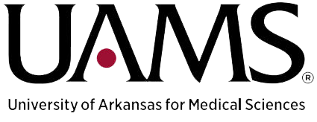
Paul Dunn Endowed Chair of ALS Research within the
J. Thomas May Center for ALS Research
Position Profile
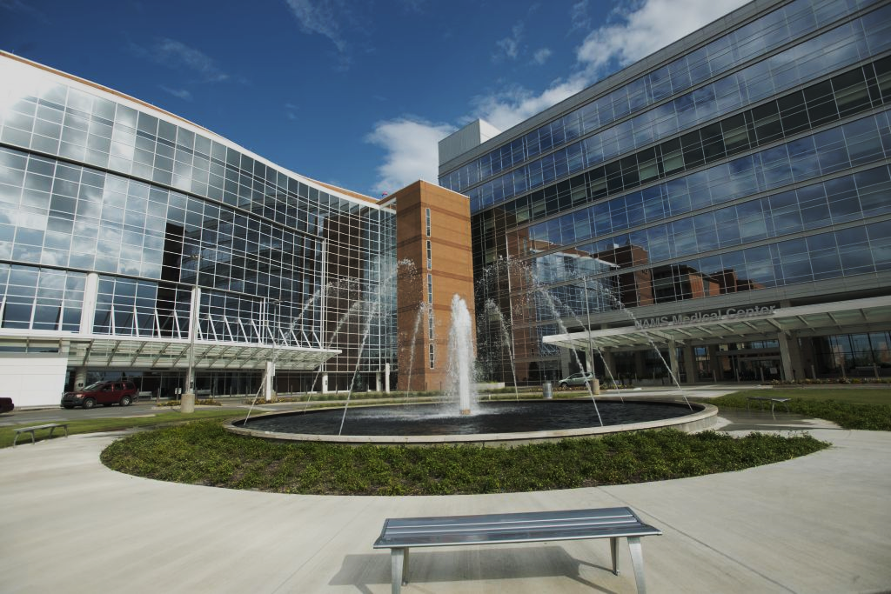
Prepared by:
UAMS Executive Search Group

Search Committee Chair:

Paul D. Drew, Ph.D.

Paul Dunn Endowed Chair of ALS Research Opportunity:
The University of Arkansas for Medical Sciences (UAMS) College of Medicine, Department of Neurobiology and Developmental Sciences seeks applications at the associate or full professor level for the position of Paul Dunn Endowed Chair of amyotrophic lateral sclerosis (ALS) Research. The Paul Dunn Endowed Chair will partner with the Tommy May ALS Endowed Clinical Chair in the Department of Neurology, to administer the J. Thomas May Center for ALS Research.
In addition to running a grant funded ALS Research program, the proposed candidate will be expected to contribute to the teaching and service missions at UAMS. The recruit will also be expected to have significant extramural grant funding.
All inquiries, nominations and applications for the position of Endowed Chair of ALS Research are welcome. Please contact Robert Moore at RDMoore@uams.edu .

About the Department:
The Department of Neurobiology and Developmental Neurosciences has a long-standing history of strength in cellular, molecular, and translational neuroscience, having been awarded two NIH-funded center grants. These centers have resulted in outstanding departmental core facilities available to support neuroscience research. The current strengths of the department are in research focused on neurodegenerative and neuroendocrine diseases, using cutting edge approaches including RNA-seq, scRNA-seq, proteogenomics, RNA-scope, and 2-Photon microscopy. An area of emerging thematic focus comprises research in physiological and pathological control of cellular plasticity and the underlying molecular mechanisms regulating cell fate. Department faculty are highly collaborative and eager to assist in the building of the Tommy May ALS center as well as develop new programmatic grant funding.
UAMS also offers a collaborative environment with researchers focused on other neurodegenerative disorders including Alzheimer’s disease (which has been funded by a program project grant for over two decades), Parkinson’s disease, multiple sclerosis, stroke, and retinal neurodegeneration . The UAMS research environment provides access to a competitive GPIBS graduate student program with a Neuroscience research track, access to medical school student researchers, UAMS Bioventures (which provides assistance for protecting and licensing intellectual property) and a range of state of the art UAMS core facilities .

About the University:

The University of Arkansas for Medical Sciences (UAMS) is the state’s only academic health sciences center, comprised of five health professions colleges (Medicine, Nursing, Pharmacy, Health Professions, and Public Health), a graduate school, seven institutes, eight Regional Centers, and a comprehensive Medical Center.

Its College of Medicine has held a unique and vital role in Arkansas for more than 130 years. UAMS is the largest public employer in the state of Arkansas with more than 11,000 employees. UAMS and its clinical affiliates: Arkansas Children’s and the VA Medical Center are an economic engine for the state with an annual economic impact of $3.92 billion. Centrally located within the state, UAMS’s Little Rock campus is a tertiary referral center and the only Level 1 adult Trauma Center and Comprehensive Stroke Center for Arkansas. UAMS was recently ranked seventh nationally on a list of Best Employers for Diversity by Forbes magazine.

UAMS is centrally located in Little Rock, Arkansas. Little Rock offers a unique professional and living environment and is located approximately 120 miles west of Memphis, Tennessee, 250 miles northeast of Dallas, Texas, and 350 miles south of St. Louis, Missouri. The Little Rock – North Little Rock communities consist of approximately 750,000 people and offer a high quality of life with a modest cost of living, excellent schools, and recreational opportunities.
Role & Responsibilities:
- Willingness to collaborate and work with researchers within the Department of Neurobiology and Developmental Sciences.
- Willingness to collaborate and work with researchers and clinicians across the UAMS campus.
- Promote ALS research on campus.
- Contribute to the teaching mission of the Department.
- Establish and maintain an annual J. Thomas May Distinguished Lectureship in ALS research.

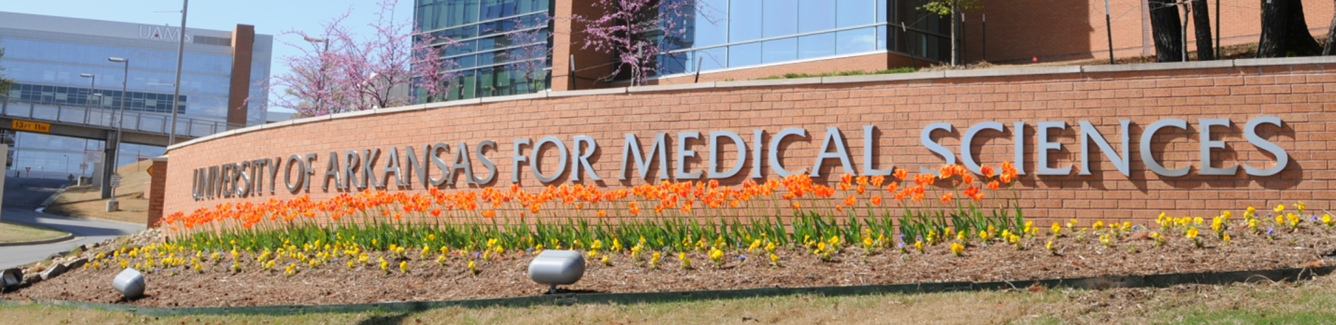Candidate Qualifications
The ideal candidate will have the following professional qualifications and personal characteristics:
- PhD, MD, or MD/PhD degree(s).
- Must be an active ALS researcher at the associate or full professor level.
- Must have active extramural grant support for ALS research.
- Must have demonstrated experience in leadership roles, such as directing a well-funded laboratory and a publication record in ALS-related research.

Personal Characteristics
- Well-developed emotional intelligence with exceptional interpersonal and communication skills
- Passion for excellence and a high level of energy and enthusiasm
- Demonstrated ability to work in a matrixed organization with multiple lines of reporting
- Demonstrated record of promoting collaboration and cultivating strong internal and external relationships
- Capacity to embrace change with an appropriate respect for culture and tradition
- Analytical and intellectual skills to lead cogent planning and sound management systems
- Demonstrated commitment to diversity
- Motivator and mentor capable of developing strong teams and developing others
- Unquestioned personal integrity

Application Process & Requirements

To assure full consideration, applications must include:
- a curriculum vitae
- a letter of interest providing a concise summary of qualifications for the position, which should include a research statement, a summary of research goals, and a statement regarding leadership philosophy.

For full consideration, applications should be received by May 31, 2022. The anticipated start date for the position is July, 2022 or after. Applications and nominations should be submitted to RDMoore@uams.edu, Robert Moore, with the UAMS Executive Search Group.
UAMS is an inclusive Affirmative Action and Equal Opportunity Employer of individuals with disabilities and protected veterans and is committed to excellence.
The safety of our team members at the University of Arkansas for Medical Sciences is our top priority. For this reason, successful applicants for this position must be fully vaccinated against Covid-19 or have filed a request for medical or religious exemption by March 15, 2022 as a condition of employment. UAMS will adhere to all federal, state and local regulations and will obtain necessary proof of vaccination prior to employment to ensure compliance.
LINK: https://medicine.uams.edu/neurobiology/research-centers/als-research/

