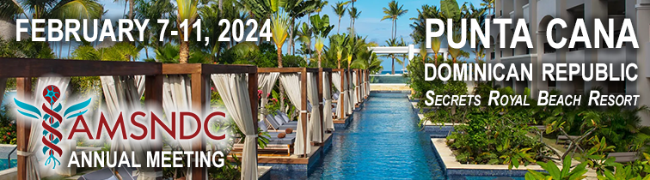

AGENDA

Wednesday, February 7
AM | Arrivals | Check In
9:00 – 3  :00 PM | Optional Tour: Scape Eco Park | Meet in lobby
4:00 – 6:00 PM | Registration Desk open - Karen Gottlieb (305-968-3625) | Hotel Lobby
6:00 - 7:30 PM | WELCOME RECEPTION | Fountain Terrace Pool
 | Dinner on your own | Resort venues
Thursday, February 8
8:00 – 8:15 AM | Welcome & Introductions / Sponsor Acknowledgement  Jack Lipton, President (MSU) / Richard Mills (Stoelting) | Baitoa Room
8:15 – 9:15 | S1: Recruitment and Retention Best Practices  Chair: Alfredo Fontanini (SUNY Stony Brook)  Jennifer Bizon (UF), Cheryl Dreyfus (Rutgers)
9:15 – 10:15 | S2: Revitalize, Repurpose, or Retire: Addressing Waning Faculty Productivity  Chair: Jack Lipton (MSU)  Paul Pfaffinger (Baylor), Chris Cowan (MUSC)
11:00 - 12:00 | Social Guest Program: Salsa Dance Class (registered guests) | On the beach
10:15 – 10:30 | Coffee Break
10:30 – 11:30 | S3: Scientist vs Chair: Can You Do Both Well?  Chair: Bill Guido (Louisville)  Panelists: Lynn Dobrunz (UTHSC), Adam Kohn (Albert Einstein),  Linda Richards (Wash U), Paul Pfaffinger (Baylor)
11:30- 12:30 | S4: Lifespan and Arc of a Neuro Chair  Chair: Alfredo Fontanini (SUNY Stony Brook)  Panelists: Michael Fox (UMass Amherst), Lucia Notterpek (U Nevada Reno), Bill Guido (Louisville)
12:30 – 1:15 | Lunch on your own | La Riviera restaurant
1:15 – 6:30 | Group Tour: Catamaran Cruise & Snorkeling  Included for all registered attendees & social guests | Hotel Lobby

Friday, February 9
8:15 – 9:15 | S5: Fundraising Strategies to Grow Unit Gifts and Endowments  Chair: John Foxe (U Rochester)  James O’Brien (U Rochester) | Baitoa Room
9:15 - 10:15 | S6: Shared Governance Strategies to Help You Excel as Chair  Chair: Jack Lipton (MSU)  Tyler Silvestri (MSU)
10:15 – 10:30 | Coffee Break
10:30 – 11:30 | S7: Update on the NIH BRAIN Initiative  Chair: John Foxe (U Rochester)  John Ngai (NIDA)
11:30 – 12:30 | S8: Problems of Prestige Publishing  John Foxe (U Rochester / Editor Eur J Neurosci)  Sabine Kastner (Princeton / Editor J Neurosci)
12:30 | Lunch on your own / Free afternoon / Resort Activities | La Riviera
2:15 – 6:30 | Optional Tour: CanAm Adventure & Cenote Swim | Hotel Lobby

Saturday, Feb 10
8:15 - 9:15 | S9: Buried Treasure – Value of Utilizing Large National Datasets  Chair: John Foxe (U Rochester)  Hugh Garavan (Vermont), Gayathri Dowling (Dir ABCD @ NIDA) | Baitoa Room
9:15 – 10:15 | S10: Bylaws – Present & Future of AMSNDC  Chair: Jack Lipton (MSU)
10:15 – 10:30 | Coffee Break
10:30 – 11:30 | S11: AMSNDC Business Meeting  Chair: Jack Lipton (MSU)
11:30 - 6:00 PM | Lunch on your own / Free afternoon / Resort Activities | Resort restaurants
6:30 – 9:30 PM | FAREWELL DINNER & REVEAL OF 2025 VENUE  (all attendees & social guests) | Babaro Beach  (near Olio)

Sunday, Feb 11
AM | Departures – SEE YOU NEXT YEAR!

Special Thanks to our Meeting Sponsors

